Marketing Research Teddy bear

1.Hopearl Peek A Boo Bear Interactive Repeats What You Say Plush Teddy Bear Toy Musical Singing Talking Stuffed Animal Adorable Electric Animate Gift for Toddlers, Brown, 11''
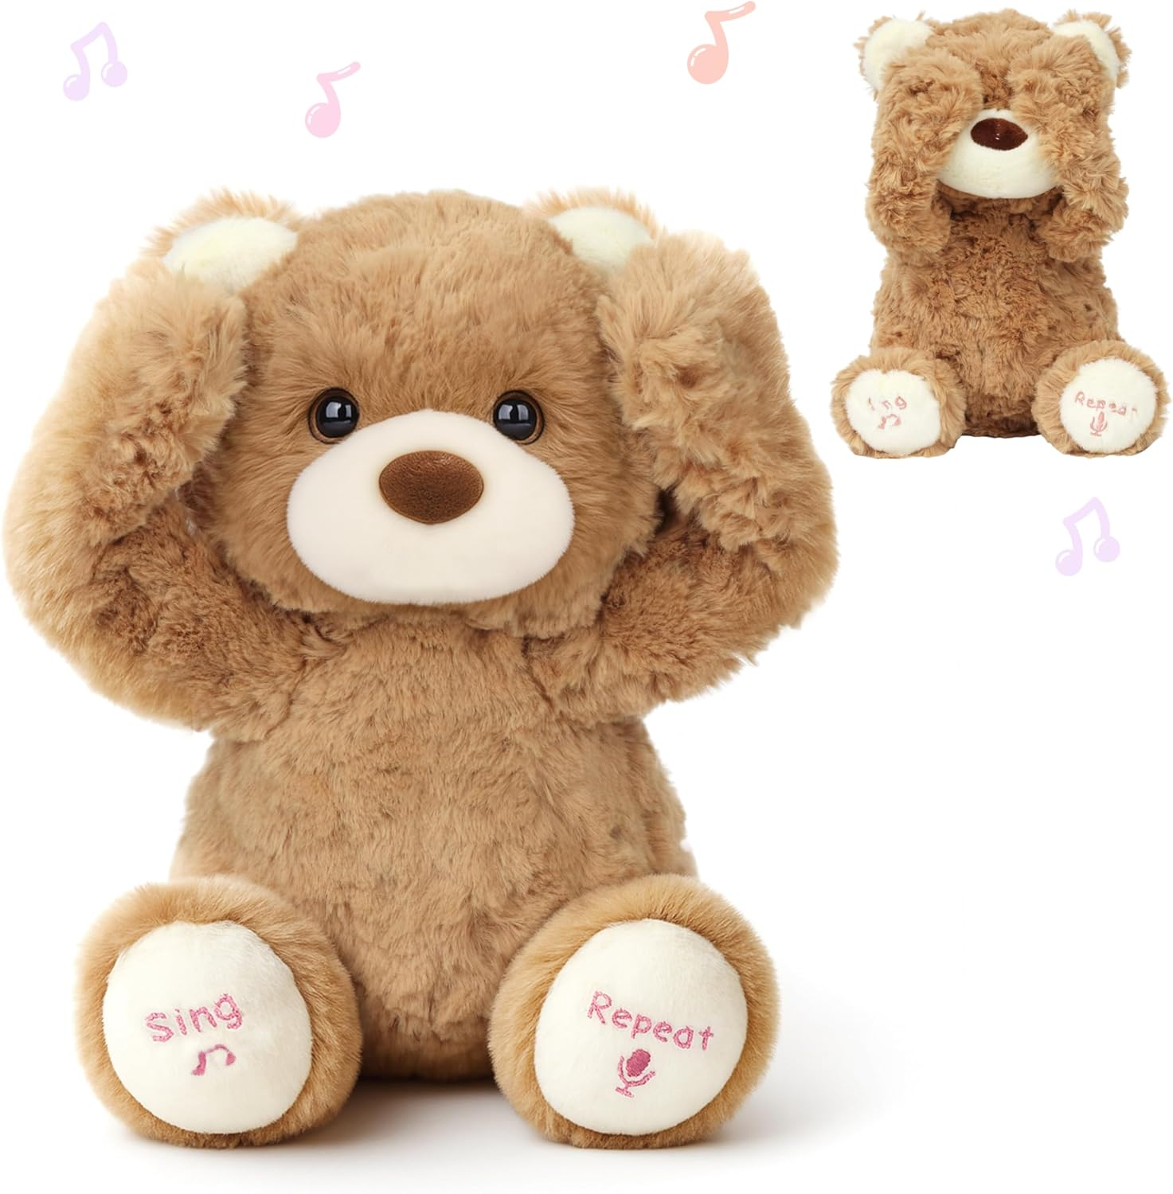

Visit the Hopearl Store
4.5 4.5 out of 5 stars (1,106)
50+ bought in past month

LKR11,264.37
LKR 36,126.87 Shipping & Import Charges to Sri Lanka Details
Style: Bear
- Bear

LKR 11,264.37LKR11,264.37
- Bear with Blanket

LKR 10,601.37LKR10,601.37
- Cow

LKR 11,264.37LKR11,264.37
- Elephant

LKR 10,269.87LKR10,269.87
- Husky

LKR 10,269.87LKR10,269.87
- Monkey with Banana

LKR 10,601.37LKR10,601.37

2.Hopearl Peek A Boo Bear with Security Blanket Interactive Repeats What You Say Plush Teddy Bear Toy Musical Singing Talking Stuffed Animal Adorable Electric...
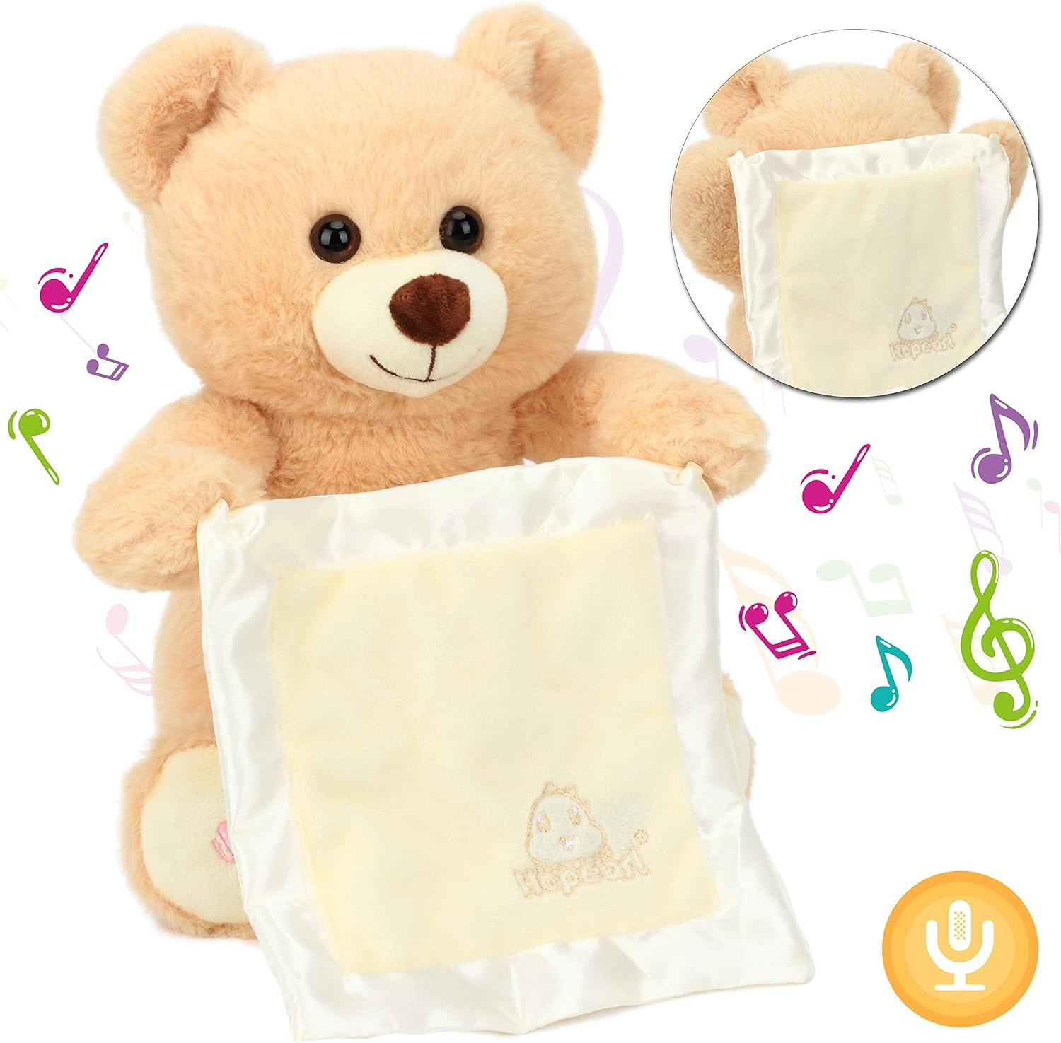

Visit the Hopearl Store
4.5 4.5 out of 5 stars (1,106)
LKR10,601.37
LKR 35,931.28 Shipping & Import Charges to Sri Lanka Details
Style: Bear with Blanket
- Bear with Blanket

LKR 10,601.37LKR10,601.37
- Bear

LKR 11,264.37LKR11,264.37
- Cow

LKR 11,264.37LKR11,264.37
- Elephant

LKR 10,269.87LKR10,269.87
- Husky

LKR 10,269.87LKR10,269.87
- Monkey with Banana

LKR 10,601.37LKR10,601.37

3. GUND Baby Flora the Bunny Animated Plush, Singing Stuffed Animal Toy for Ages 0 and Up, Cream, 12" (Styles May Vary)

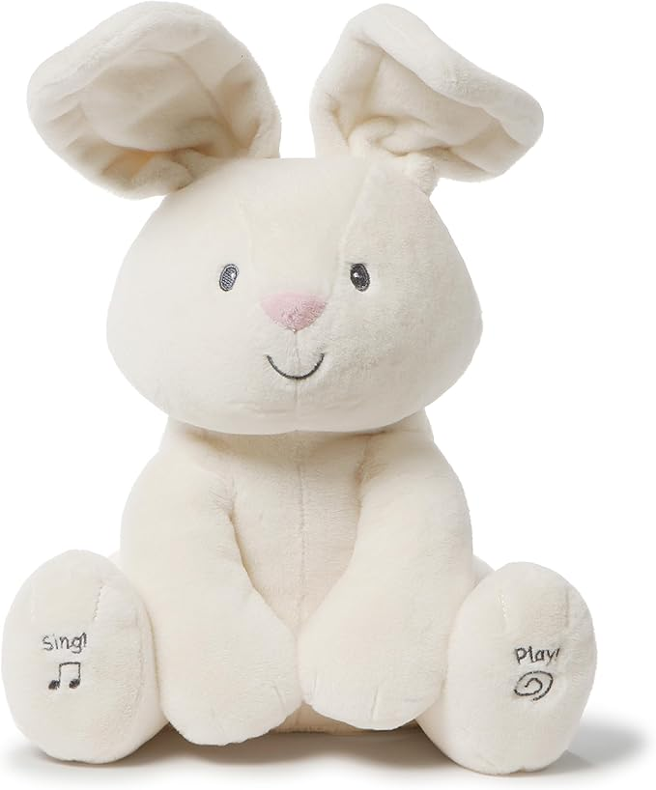

4.8 4.8 out of 5 stars (40,557)
This item cannot be shipped to your selected delivery location. Please choose a different delivery location.
Style: Flora
- Alora

LKR 9,394.71LKR9,394.71
- Buttermilk

LKR 14,072.18LKR14,072.18
- Kissy

LKR 12,895.35 with 14 percent savingsLKR12,895.35
LKR14,914.18
- Modern

LKR 11,897.54 with 17 percent savingsLKR11,897.54
LKR14,251.18
- Peeki

LKR 12,858.88 with 14 percent savingsLKR12,858.88
LKR14,914.18
- Flora

13 options from LKR 8,691.93

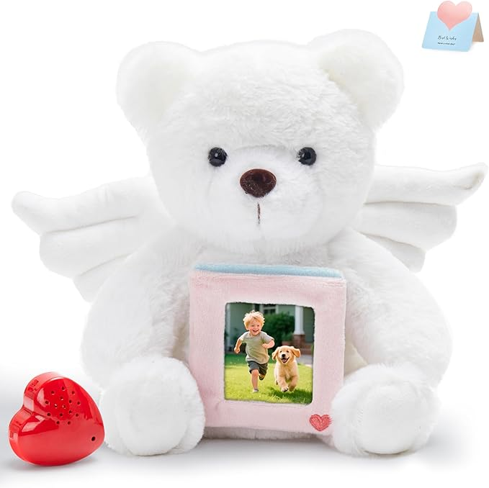
4. 10" Heartbeat Recordable Guardian Angel Bear, Voice Recorder Teddy Bear w/30 Sec Recorder, Comforting Plush Toy with Photo Frame Messages Recording Playback Gifts for Remembrance Newborns Birthday

Visit the CozyWorld Store
4.8 4.8 out of 5 stars (25)
50+ bought in past month
LKR8,284.18
LKR 32,298.04 Shipping & Import Charges to Sri Lanka Details
Color: Angel Bear
- 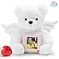

LKR 8,284.18LKR8,284.18
- 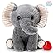

LKR 8,284.18LKR8,284.18
- 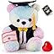

LKR 7,926.16LKR7,926.16
- 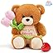

LKR 8,257.66LKR8,257.66

5. SpecialYou 10’’ Brown Teddy Bear Stuffed Animal with Voice Recorder Cute Recordable Bear Plush Toy with Love You Mom for Women Mom

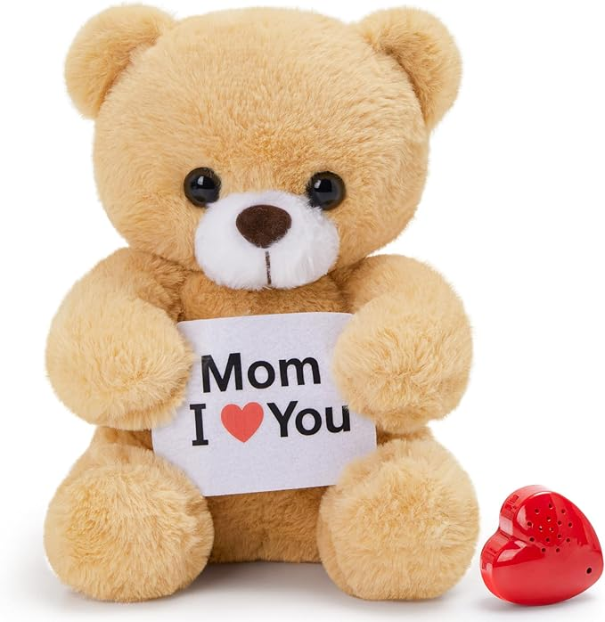

Visit the SpecialYou Store
4.4 4.4 out of 5 stars (19)
100+ bought in past month
-13% LKR6,626.68
List Price: LKR 7,621.18List Price: LKR7,621.18
LKR 28,363.14 Shipping & Import Charges to Sri Lanka Details
- Recording Teddy Bear Stuffed Animal: Our voice-recording teddy bear can speak and sing, it repeats no matter what language you speak or what content you say and it can record sound around it.The voice it makes is very strange, it can change the original timbre of sound to make it in its voice.Record what you want to say and express it with a puppet.

6. Cuddle Barn - Mother Goose Animated Stuffed Animal, Talking, Story-Telling Plush Toy for Kids, 14
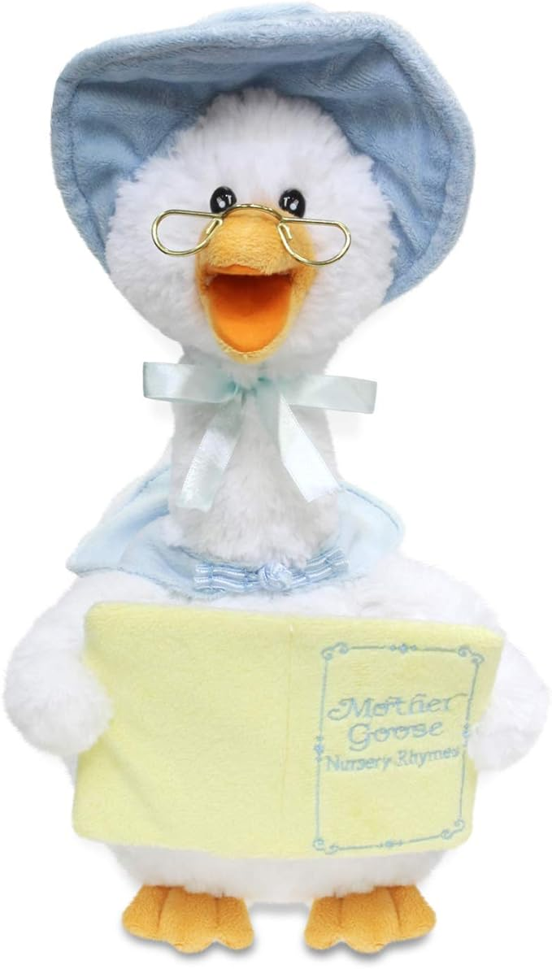

Visit the Cuddle Barn Store
4.7 4.7 out of 5 stars (3,447)
50+ bought in past month

LKR 13,919.68 with 7 percent savings-7% LKR13,919.68
List Price: LKR 14,914.18List Price: LKR14,914.18
LKR 59,189.32 Shipping & Import Charges to Sri Lanka Details
Style: Mother Goose - Blue
- Mother Goose - Blue

LKR 13,919.68 with 7 percent savingsLKR13,919.68
LKR14,914.18
- Mother Goose - Pink

LKR 13,919.68LKR13,919.68

- DELIGHTFUL & ENTERTAINING - Mother Goose stands 14” tall and has glasses, hat, shawl and book. Her head turns and her beak moves while she reads nursery rhymes to your child.

- READS 7 CLASSIC NURSERY RHYMES - Your child will love listening to Mother Goose as she holds her book and recites 7 different nursery rhymes including Jack and Jill, Hickory Dickory Dock, Little Bo Peep, Humpty Dumpty, Twinkle Twinkle Little Star, Little Miss Muffet and This Little Piggy. She speaks in a soothing, motherly voice along to twinkling music.

- PERFECT GIFT - Cuddle Barn toys will stand out from all the rest! Whether its for a birthday, celebration, or any special occasion, Cuddle Barn’s animated plush toys and soft plush friends make the perfect gift that will bring endless smiles and lasting memories to all. Recommended for ages 18M+.

- BATTERIES INCLUDED - Comes with 3 AA batteries. All Cuddle Barn animated plush creations come with batteries included so your kiddo does not need to wait to play when their new friend comes home!

- BRINGING PLUSH TO LIFE - Pairing cutting-edge animation with entertaining sounds, Cuddle Barn's animated plush toys are high quality and look realistic as they sing, talk, move or light up. These super soft cuddly plush toys are sure to be your child’s new favorite toy.

7. Peek a Boo Elephant Toy, Interactive Singing Plush Elephant Toy with Flapping Ears and Hearts, Musical Stuffed Animal for Babies and Toddlers

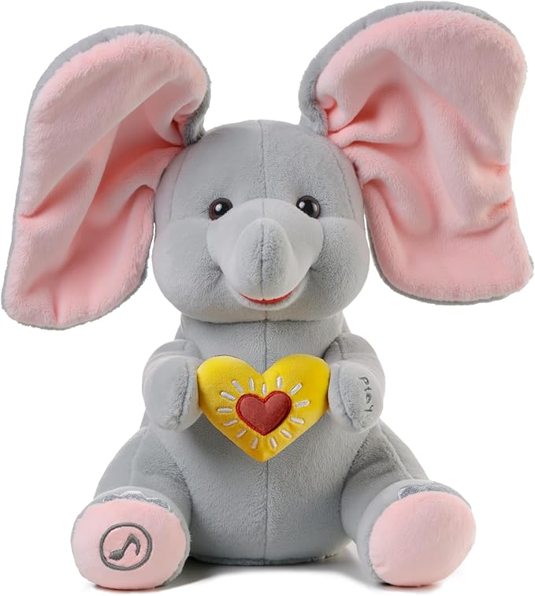

Visit the Cuteoy Store
4.0 4.0 out of 5 stars (228)

LKR 9,938.37LKR9,938.37
LKR 35,294.80 Shipping & Import Charges to Sri Lanka Details
Style: Panda
- Panda

LKR 9,938.37LKR9,938.37
- Pig

LKR 9,938.37LKR9,938.37

- CUTE FIGURE: This animated plush toy is a cute and fuzzy panda bear. When you press the left button, it will say “Peek-a-Boo” and sing songs, you can press the button to switch between songs, it contains 5 songs in total. Press the right button, it will repeat what say. Press the right button, it will repeat what say. Meanwhile it can make cute Peek-A-Boo hand motions while singing or speaking.

- HOW TO PLAY: First adults should open the battery box on the bottom of the panda with a screwdriver. Then you need to put in 3 AA batteries (NOT INCLUDED), and turn the switch to “ON”. At last, just ask your kids to press the button on its feet. Thus, kids can interact with the panda and share it with friends.

- INTERACTIVE FUNCTIONS: This electric stuffed panda has a soft and furry body. It can sing, interact and repeat. It also helps to promote kids’ development of hearing, acting, and the ability of imitating its movement. I believe your little one will like the surprise. Do you want to play with it?

- WHAT IS PANDA? The Giant Panda, literally "black and white cat-foot", also known as panda bear or simply panda, is a bear native to south central China. It is easily recognized by the large, distinctive black patches around its eyes, over the ears, and across its plump body. Bamboo is their staple food. With cute appearance and lovely actions, they are named the national treasure of China.

- CAUTION: Do not wash in water and keep away from fire. It requires 3 AA batteries which are not included. In order to prolong the life of the product, if you encounter any problems during use, please leave a message on Amazon and we will respond as soon as possible and try to help you.

8. Peek A Boo Panda Bear Plush Toy Interactive Electric Stuffed Animal Repeats What You Say Singing Talking Musical Plushies Gifts for Christmas Birthday 11''
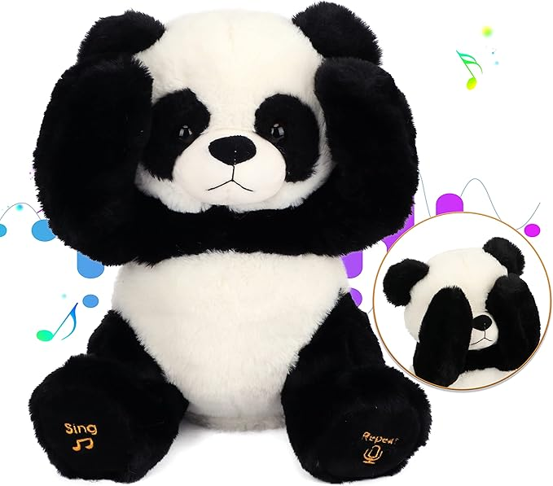

Visit the Cuteoy Store
4.0 4.0 out of 5 stars (228)

LKR 9,938.37LKR9,938.37
LKR 35,294.80 Shipping & Import Charges to Sri Lanka Details
Style: Panda
- Panda

LKR 9,938.37LKR9,938.37
- Pig

LKR 9,938.37LKR9,938.37
- CUTE FIGURE: This animated plush toy is a cute and fuzzy panda bear. When you press the left button, it will say “Peek-a-Boo” and sing songs, you can press the button to switch between songs, it contains 5 songs in total. Press the right button, it will repeat what say. Press the right button, it will repeat what say. Meanwhile it can make cute Peek-A-Boo hand motions while singing or speaking.

- HOW TO PLAY: First adults should open the battery box on the bottom of the panda with a screwdriver. Then you need to put in 3 AA batteries (NOT INCLUDED), and turn the switch to “ON”. At last, just ask your kids to press the button on its feet. Thus, kids can interact with the panda and share it with friends.

- INTERACTIVE FUNCTIONS: This electric stuffed panda has a soft and furry body. It can sing, interact and repeat. It also helps to promote kids’ development of hearing, acting, and the ability of imitating its movement. I believe your little one will like the surprise. Do you want to play with it?

- WHAT IS PANDA? The Giant Panda, literally "black and white cat-foot", also known as panda bear or simply panda, is a bear native to south central China. It is easily recognized by the large, distinctive black patches around its eyes, over the ears, and across its plump body. Bamboo is their staple food. With cute appearance and lovely actions, they are named the national treasure of China.

- CAUTION: Do not wash in water and keep away from fire. It requires 3 AA batteries which are not included. In order to prolong the life of the product, if you encounter any problems during use, please leave a message on Amazon and we will respond as soon as possible and try to help you.

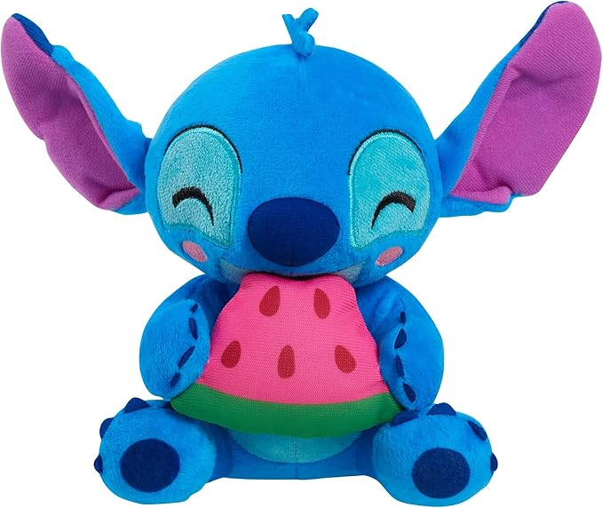
9. Disney Stitch Small Plush Stitch and Watermelon, Stuffed Animal, Blue, Alien, Kids Toys for Ages 2 Up by Just Play

Visit the Just Play Store
4.8 4.8 out of 5 stars (1,038)
Amazon's Choice
100+ bought in past month

LKR 3,311.68LKR3,311.68
LKR 29,039.40 Shipping & Import Charges to Sri Lanka Details
Customers usually keep this item.
- Includes: Stitch plush toy.
- Stitch loves food! The Disney Stitch Feed Me Series Beanbag Plush Stitch toy with watermelon features kawaii-styled, cheerful Stitch happily snacking on a slice of watermelon.
- Made with vibrant, super-soft fabrics for supreme cuddle-ability.
- 7-inches tall, Stitch is a fun, huggable size. Kids can bring him everywhere they go, turning any outing into a sweet adventure.
- Kids will love to play with Stitch and pretend he is their own mischievous buddy, just like in Disney’s Lilo & Stitch movie. And Stitch’s appetite might inspire reluctant eaters to try a healthy piece of fruit!
- Collect all three Disney Stitch Feed Me Series Beanbag Plush toys: Stitch with Watermelon, Stitch with Coconut, and Stitch with Pineapple (each sold separately).

10. Onsoyours Cute Bear Plush Toy Stuffed Animal Bear Soft Anime Plush Pillow for Kids (Brown Bear, 12")
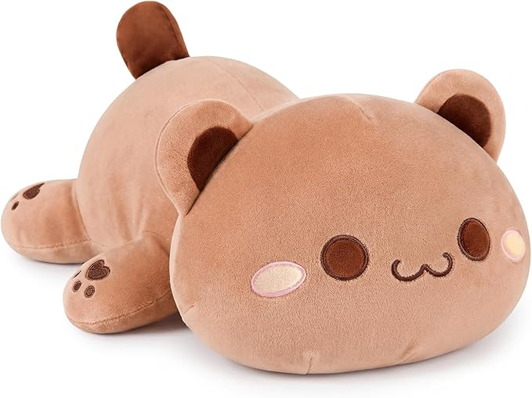

Visit the Onsoyours Store
4.8 4.8 out of 5 stars (5,588)
Amazon's Choice
3 sustainability features

LKR 5,602.35 with 5 percent savings-5% LKR5,602.35
Typical price: LKR 5,917.28Typical price: LKR5,917.28
LKR 30,574.24 Shipping & Import Charges to Sri Lanka Details
Save 5% on 2 select item(s) Shop items
Save 8% on 5 select item(s) Shop items
Color: Brown Bear
- 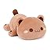

LKR 5,602.35 with 5 percent savingsLKR5,602.35
LKR5,917.28
- 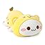

LKR 6,295.18LKR6,295.18
- 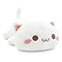

LKR 5,632.18LKR5,632.18
Size: 12"
- 12"
- 20"
- 25"
Customers usually keep this item.
- Material: Plush Kitty is filled with elastic cotton which is softer than ordinary, skin-friendly fabrics give you better skin touch feeling, make the pillow way soft and comfortable.
- Size: 12" (Manual measurement may be 0.5-1.5 inch error). The pillow has a suitable size which is a perfect feeling to hug.
- Suitable: Children/Family/Friends /Relative can't miss it! Great choice for hugging bed pillow for both adult and kid too. Suitable for bedroom, living room, family, office, etc.
- Best Gift: Just surprise your friends with this adorable, unique and soft plush toy pillow.
- Important Note : The plush kitty comes by vacuum packaging, so it is flat, after you unpacking, please do something make the cotton loose or put it in the sun or to the dryer, it will recover better, thank you for your understanding.

